Vacuum Cleaner AI Problem
Aim
To design a simple AI-based vacuum cleaner agent that cleans all dirty rooms by sensing the environment and performing appropriate actions.

Objective
- To understand the concept of an intelligent agent.
- To simulate the working of a vacuum cleaner in AI.
- To clean all dirty rooms automatically.
- To minimize unnecessary actions.

Algorithm
- Start.
- Initialize the room states (Clean/Dirty).
- Place the vacuum cleaner in the starting room.
- Check the current room.
- If the room is Dirty, clean it.
- Move to the next room.
- Repeat Steps 4–6 until all rooms are clean.
- Display the final room states.
- Stop.

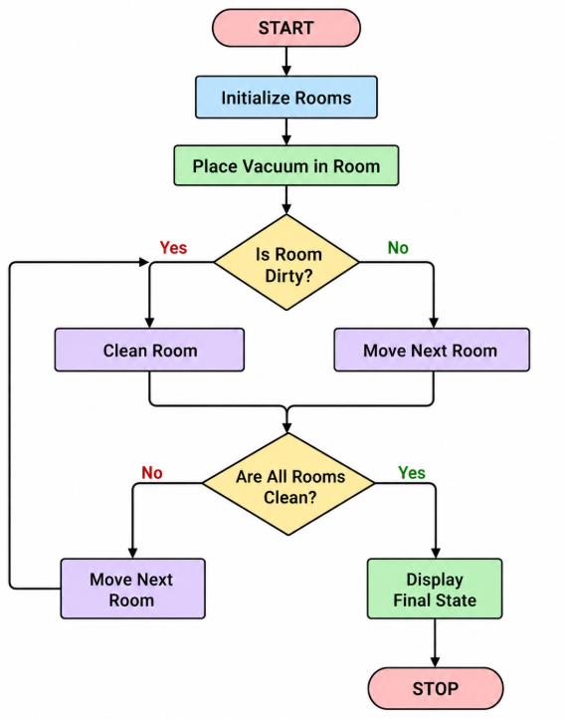
PROGRAM
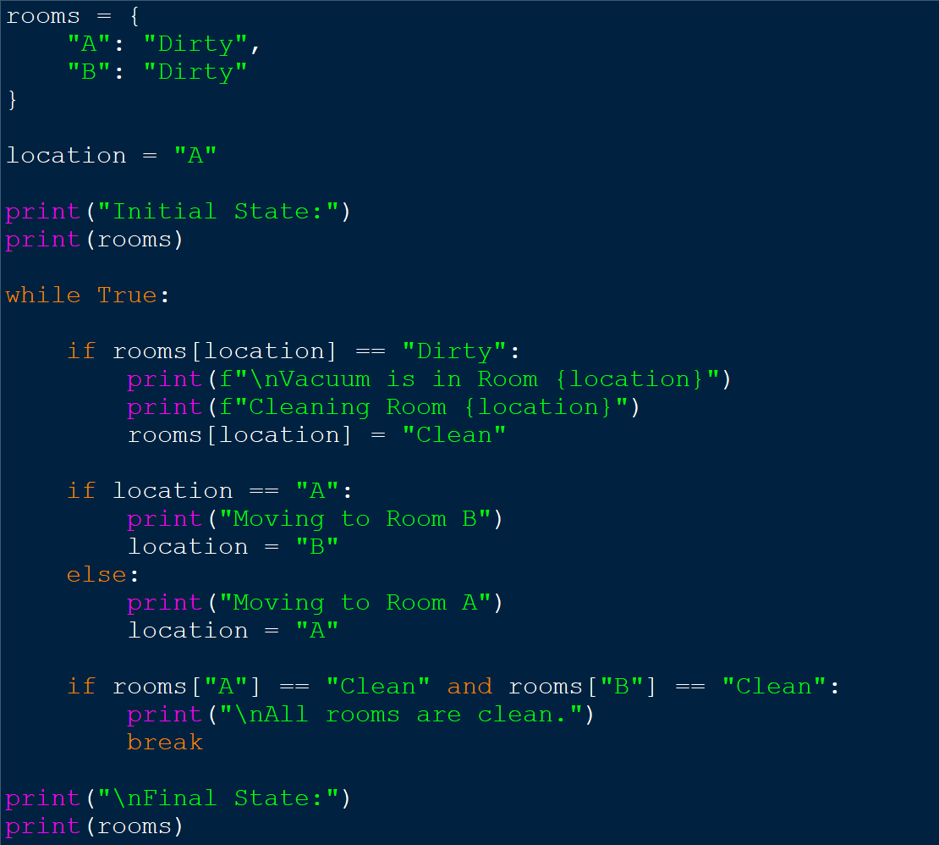

OUTPUT
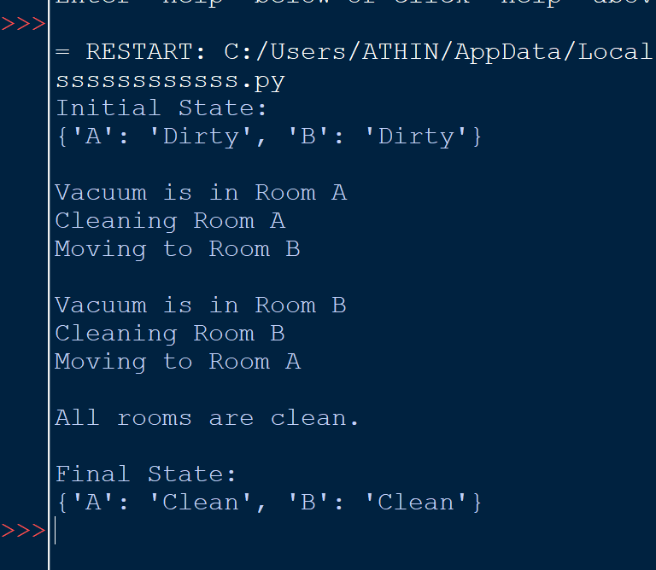Result
The AI vacuum cleaner agent successfully sensed the environment, cleaned all dirty rooms, and stopped after completing the task. Thus, the Vacuum Cleaner AI Problem was implemented successfully using Python.

